**Python Echo Server Project:**

* Echoes input string sent from the client to the server.
* Server program waits for client strings and echoes string
* Size limit: 1KB in data to send
* **Interaction steps:**
  1. Program_server starts up and waits for client’s connection. The server is waiting on localhost and port number ‘8888’
  2. Program_client starts run and asks to enter server IP to connect. Use localhost.
  3. Program_server and Program_client connects
  4. Program_client sends any string to program_server
  5. Program_server sends received string in capital back to program_client
     + Ex: server receives “abcd”, capitalizes to “ABCD” and send back to client
  6. Both programs continue…
* Any type of socket can be used

**Example Process flow:**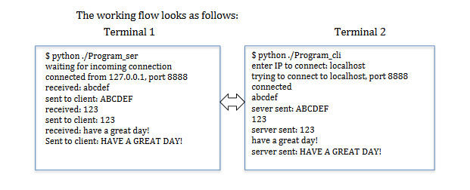

**Recitation Lecture Notes (Lab 9):**

* Creating multiple clients to connect to a server within a WIFI network
* Clients do not connect directly to other server due to security reasons
* Local area network: only devices within the same network can access a server that was created within the network. The only way for people for other people to access the network, you must make your modem a public IP address.